MP3: Page Manager

Joshua Clapp

UIN: 930004089

CSCE410: Operating System

Assigned Tasks

Main: Completed.

Bonus Option 1:

none.

Bonus Option 2:

none.

Bonus Option 3:

none.

Bonus Option 4:

none.

System Design

* Interrupt flips page on
* Finds missing page and sets bits
* Can say present/ directory into proper boxes

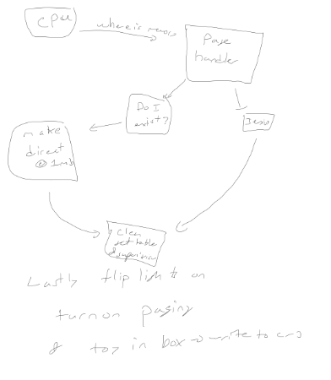

Code Description

I changed page_table.C, to compile the code type make, ./copykernel.sh and then run bochs.

page_table.C: init_paging :

This method was used to pass in the process, kernel, and shared pool into the class.

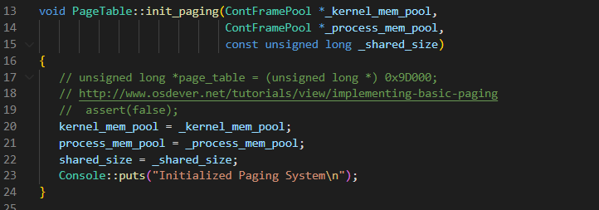

page_table.C: PageTable():

This method was to set the page table to the supervisor, load the first instance into the directory and then load the entire first table into the page directory. Lastly, take set the bits to user level, read, and not present in the page directory.

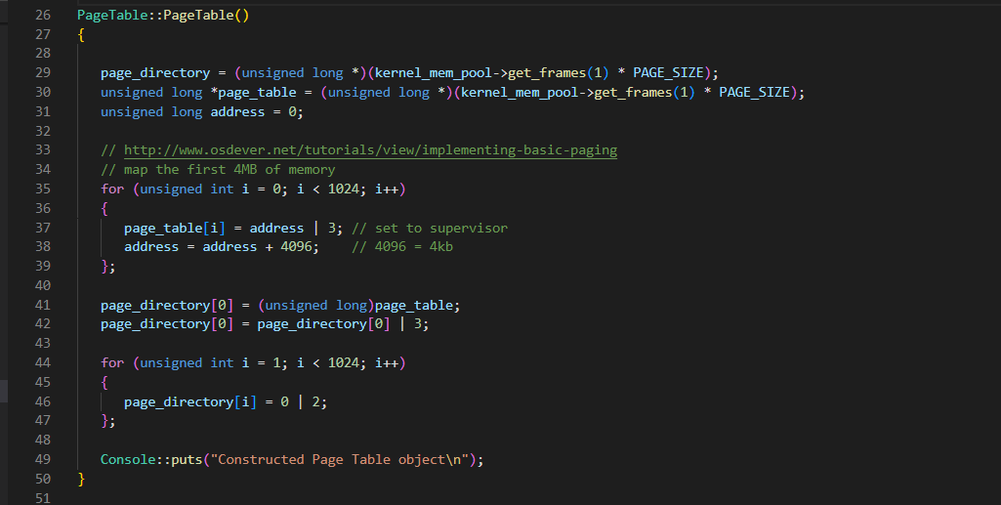

page_table.C: load() :

This method was loaded in the page directory into the register.

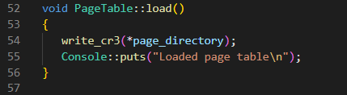

page_table.C: enable_paging() :

This method turned on paging and set the paging bit to 1.

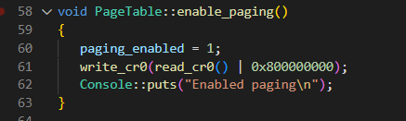

cont_frame_pool.C: handle_fault():

This method reads the page directory to see if there is a directory already created and allocated. Check if there is an error code that is unhandled, and now see if the directory is allocated to 1Mb, and if not allocate the frames setting to supervisor mode. Otherwise, check the first 12 bits and allocate the page to user mode.

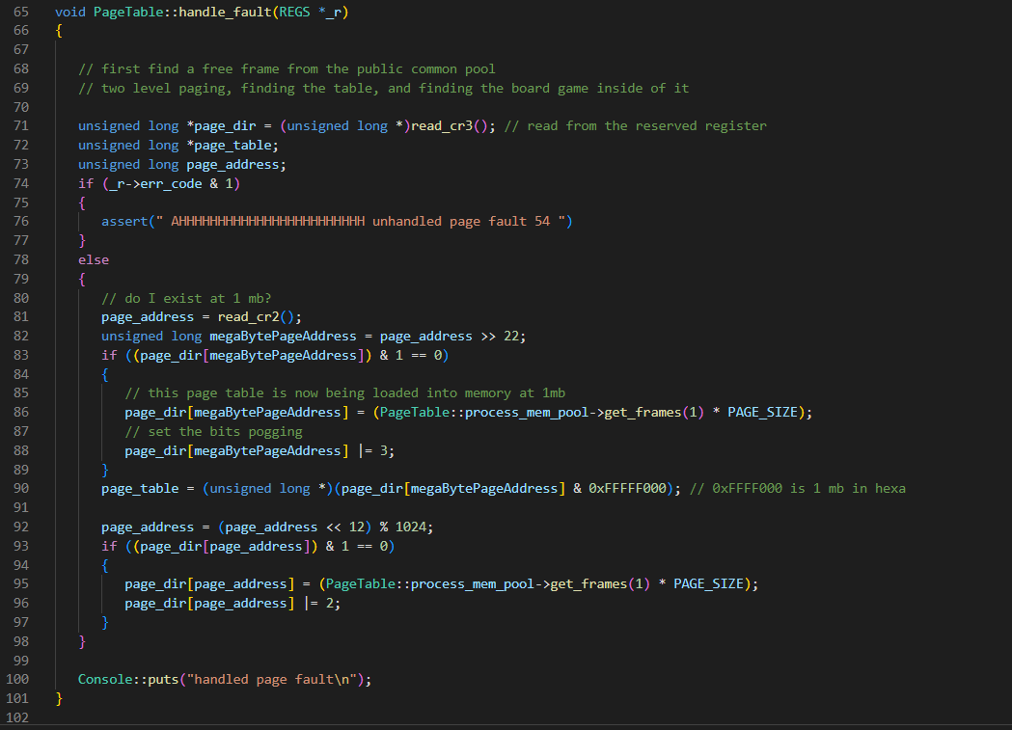

Testing

For testing, I relied on the provided test functions and added nothing. I am not sure how to further test memory allocation and paging. I think the coverage of the testing is comprehensive as it loops through all of NACCESS.